Busti Fire Department
Annual
Christmas Tree Lighting
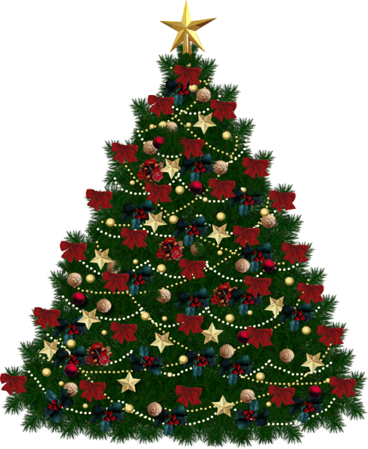
This Photo by Unknown Author is licensed under CC BY-NC

and
Santa’s Arrival
Saturday, December 1st; 7pm
at the Triangle in the Hamlet
Refreshments to follow at the Fire Hall

