CHAUTAUQUA COUNTY HIGHWAY SUPERINTENDENT ASSOCIATION

TOYS FOR KIDS

DONATE A $10 OR LESS
UNWRAPPED TOY BY December 12TH

ALL TOYS ARE GIVEN TO KIDS IN
CHAUTAUQUA COUNTY
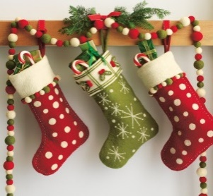

THANK YOU FOR YOUR SUPPORT!!!!

DONATIONS CAN BE MADE AT TOWN OF BUSTI, 125 CHAUTAUQUA AVE, LAKEWOOD

