Hazeltine Public Library
Busti Fire Department
are sponsoring

THE
Red Cross Disaster Recovery Program

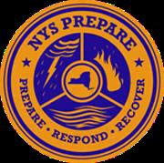

Red Cross is bringing Citizen Preparedness to this area

In one hour you can learn how to prepare and how to recover from natural and man made disasters

FREE and OPEN to all
Tuesday, September 10, 2019
6:30 PM
Busti Fire Hall Meeting Room

RESERVATIONS REQUESTED
Call the library at 716.487.1281 to reserve your spot

