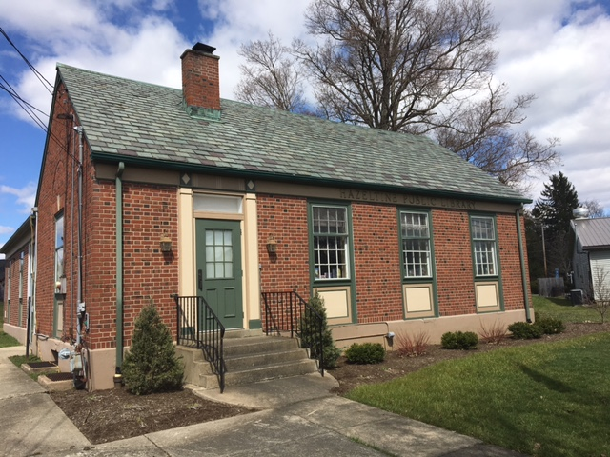
Bounce House + Kids Games
TarpSkunk Baseball Players and Coaches signing autographs
12 – 1 PM ONLY

HAZELTINE PUBLIC LIBRARY
Baseball Game Ticket Giveaway!
OPEN HOUSE CELEBRATION
Hot Dogs and Drinks
JUNE 12, 2022 12 PM – 2 PM
(this is an outdoor event, if there is bad weather we will move inside but many activities will not happen)
Learn About Volunteer Opportunities
Ice Cream Eating Contest
Get Your Library Card

FREE BOOKS
Informational Vendors
Therapy Dog

FREE FAMILY FRIENDLY EVENT OPEN TO ALL
PARKING AVAILABLE AT THE BUSTI FIRE HALL

Hazeltine Public Library 891 Busti Sugargrove Rd. Jamestown, NY ph. 716.487.1281

