Busti Fire Department
Annual
Christmas Tree Lighting
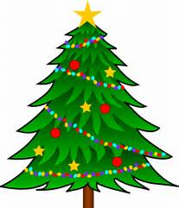
and
Santa’s Arrival
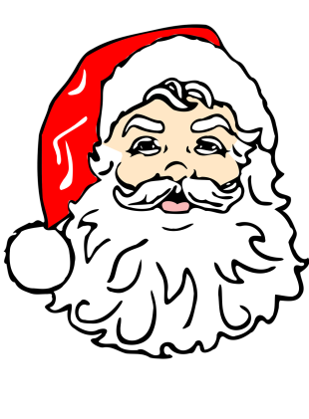
Saturday, December 3rd; 7pm
at the Triangle in the Hamlet
Refreshments to follow at the Fire Hall

