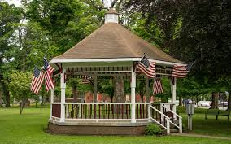
Busti Gazebo Concerts
from 6:30 until 8:30 p.m.

Featuring

- July 13 – Old Dawg Blue Grass

- July 20 – Rustic Ramblers

- July 27 – Happy Days

- August 3 – The New Smith Brothers Band (bluegrass/country)

- August 10 – Pat Cook

- August 17 – Happy Days

- August 24 – Rustic Ramblers

- August 31 – Busti Church of God – Faith, Praise, & Song

Everyone is welcome. Please bring your lawn chair and enjoy an evening of great entertainment. The event is sponsored by The Busti Hamlet Development Association and the Chautauqua Region Community Foundations.

